**CHANDIGARH UNIVERSITY**

**UNIVERSITY INSTITUTE OF ENGINEERING**

**DEPARTMENT OF COMPUTER SCIENCE AND ENGINEERING**



|  |  |
| --- | --- |
| **Submitted by:** | **Submitted To:** Ajay Kumar (E13141) |
| **Subject Name:** | Machine Learning Lab |
| **Subject Code:** | 20CSP-317 |
| **Branch:** | CSE |
| **Semester:** | 5th |

LAB INDEX

**Experiment 3**

**1. Aim/Overview of the practical:**

**Study relationships between two continuous (quantitative) variables using Simple Linear Regression**

**2. Source Code:**

import matplotlib.pyplot as plt

import numpy as np

from sklearn import datasets, linear_model

from sklearn.metrics import mean_squared_error

db=datasets.load_diabetes()

#print(db.target)

db_x=db.data[:,np.newaxis,2]

#db_x=db.data

#print(db_x)

db_x_train=db_x[:-50]

db_x_test=db_x[-50:]

db_y_train=db.target[:-50]

db_y_test=db.target[-50:]

model=linear_model.LinearRegression()

model.fit(db_x_train,db_y_train)

db_y_predicted=model.predict(db_x_test)

print("MSEis:",mean_squared_error(db_y_test,db_y_predicted))

print("Weight:",model.coef_)

print("Intercept:",model.intercept_)

plt.scatter(db_x_test,db_y_test)

plt.plot(db_x_test,db_y_predicted)

plt.show()

**3. Result/Output**

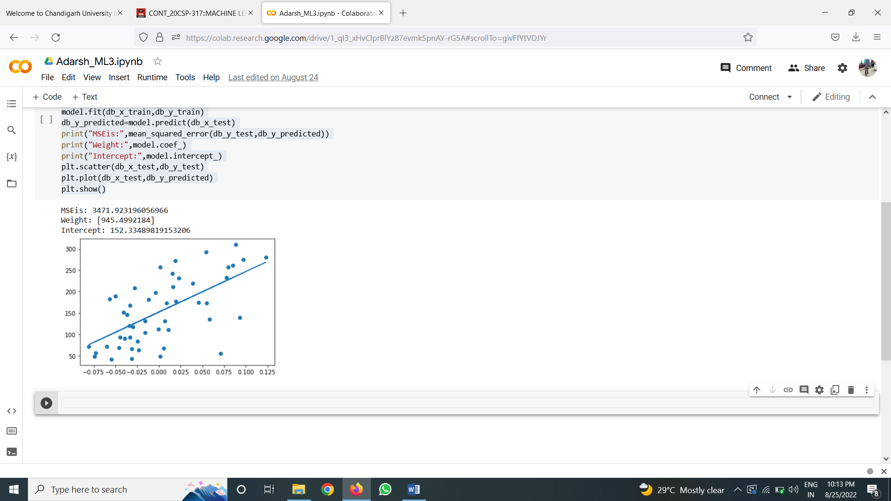

**Learning outcomes (What I have learnt):**

**1. Types of relationships**

**2. Why Regression lines are important?**

**3. Where linear regression is used?**

**Evaluation Grid :**

|  |  |  |  |
| --- | --- | --- | --- |
| **Sr. No.** | **Parameters** | **Marks Obtained** | **Maximum Marks** |
| **1.** | **Student Performance  (Conduct of experiment) objectives/Outcomes.** |  | **12** |
| **2.** | **Viva Voce** |  | **10** |
| **3.** | **Submission of Work Sheet (Record)** |  | **8** |
|  | **Total** |  | **30** |